Is there evidence that increasing man-caused greenhouse gases results in higher global average temperatures?

Class Prep

Data

Evidence of correct data

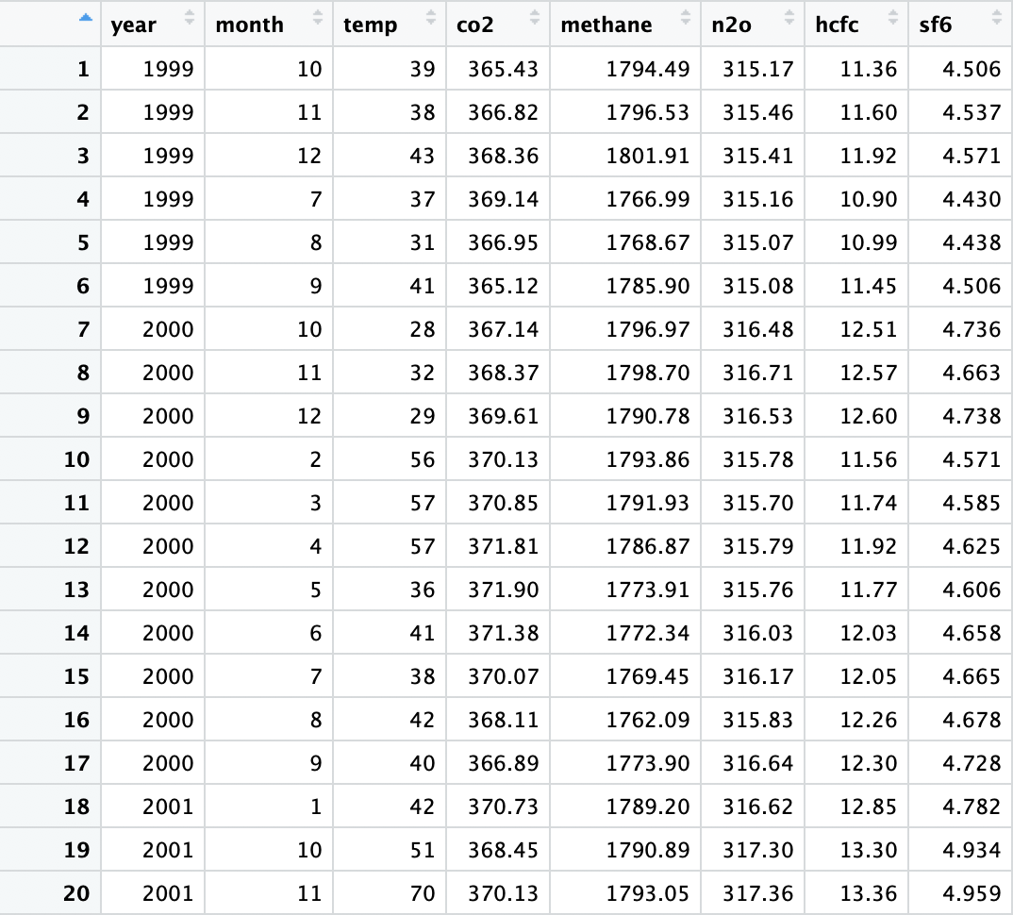

Response variable: The temperature (Quantitative)

Explanatory variables: concentration of co2 gases (Quantitative), concentration of methane gases (Quantitative), concentration of n2o gases (Quantitative), concentration of hcfc gases (Quantitative), concentration of sf6 gases (Quantitative

The scatterplot of temperature and n2o



Correlation coefficients:

0.6419052

It appears a positive linear correlation.

Scatterplot of temperature and hcfc



Correlation coefficients:

0.5359126

It appears a positive linear correlation.

The scatterplot of temperature and sf6



Correlation coefficients:

0.6420868

It appears a positive linear correlations.